**NAME: PAWAN KHIANI**

**ID: KWOWFL3479**

**BATCH: 02**

**COURSE: MOBILE APP DEVELOPMENT USING FLUTTER**

**ASSIGNMENT # 04**

**QUESTION # 01:**

How to duplicate repeating items inside a Dart list?

Problem

Consider the code:

final List<Dynamic>_nameList = [Bilal, Bilal, Bilal, Owais, Owais, Owais]

What can to be done in order to not repeat Bilal and Owais multiple times?

**ANSWER:**

In dart, the list can be duplicated using [list name.toSet().toList] is used.

**SOURCE CODE:**

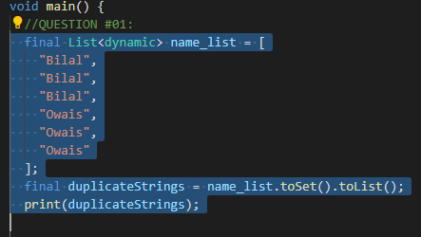

**OUTPUT:**



**QUESTION # 02:**

Let’s say you are given a list saved in a variable:

Consider a = [1, 4, 9, 16, 25, 36, 49, 64, 81, 100].

Write a code that takes this list and makes a new list that has only the even elements of this list in it.

**ANSWER:**

**QUESTION # 03:**

Ask the user for a number and determine whether the number is prime or not.

**ANSWER:**

**SOURCE CODE:**

  print('Enter number to check prime or no');

  int? num = int.parse(stdin.readLineSync()!);

  print('$num');

  if (checkPrime(num)) {

    print('$num is a prime');

  } else {

    print('$num is not a prime');

  }

}

bool checkPrime(int num) {

  if (num <= 1) {

    return false;

  }

  for (int i = 2; i <= sqrt(num); i++) {

    if (num % i == 0) {

      return false;

    }

  }

  return true;

**OUTPUT:**

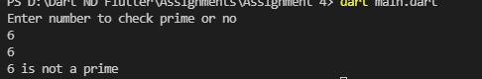

**QUESTION # 04:**

Write a program to print multiplication table of 7 length 15 using loop.

**ANSWER:**

**SOURCE CODE:**

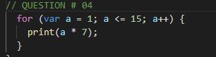

**OUTPUT:**

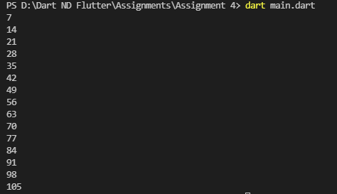

**QUESTION # 05:**

Write a program to print items of the following array using for loop:

fruits = [“apple”, “banana”, “mango”, “orange”, “strawberry”].

**ANSWER:**

**QUESTION # 06:**

Write a program to print multiples of 5 ranging 1 to 100.

**ANSWER:**

**SOURCE CODE:**

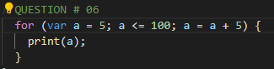

**OUTPUT:**

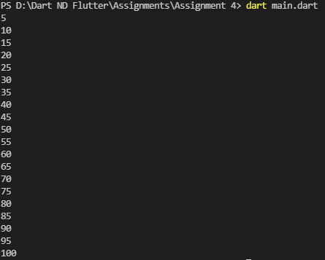

**QUESTION # 07:**

The Temperature Converter: It’s hot out! Let’s make a converter based on the steps here.

a. Store a Celsius temperature into a variable.

b. Convert it to Fahrenheit & output “NNoC is NNoF”.

c. Now store a Fahrenheit temperature into a variable.

d. Convert it to Celsius & output “NNoF is NNoC”.

**ANSWER:**

**QUESTION # 08:**

Write a program to create a calculator for +, -, *, / & % using if statements. Take the following input:

a. First number Second number

b. Operation (+, -, *, /, %)

Compute & show the calculated result to user.

**ANSWER:**

**QUESTION # 09:**

Write a program that takes a character (I. e. string of length 1) and returns true if it is a vowel, false otherwise.

**ANSWER:**

**QUESTION # 10:**

Write a program to reverse a string. For example, if my string is "natsikaP nawaJ" then my result will be "Jawan Pakistan".

**ANSWER:**

**QUESTION # 11:**

How are duplicates removed from a given array? [Ahmed, Bilal, Muhammad, Owais, Muhmmad, Ali, Ahmed]

**ANSWER:**

**QUESTION # 12:**

Find the missing number in array of 1 to 100?

**ANSWER:**

**QUESTION # 13:**

Find the largest and smallest number in an unsorted integer array?

**ANSWER:**

**QUESTION # 14:**

Find all pairs of an integer array whose sum is equal to a given number?

**ANSWER:**